**IF**



**THEN**

**Q**

**d**

The Law of **DEMAND**



**P**

**THEN**

**IF**

**Q**

**d**

**P**

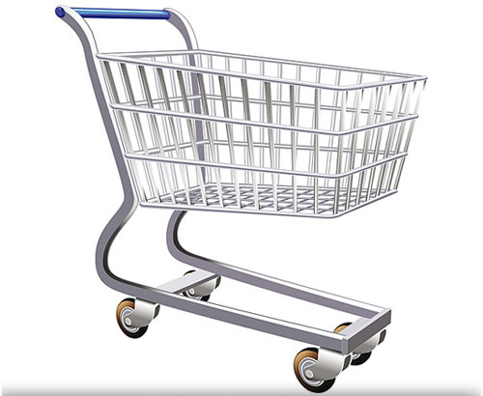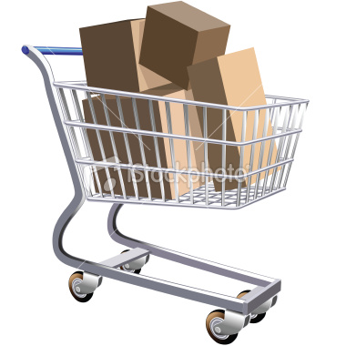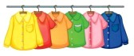

**This is called a “__________” relationship**

**This is called an “__________” relationship**



**THEN**

**THEN**

The Law of **SUPPLY**

**Q**

**s**

**Q**

**s**

**P**

**P**

**IF**

**IF**

