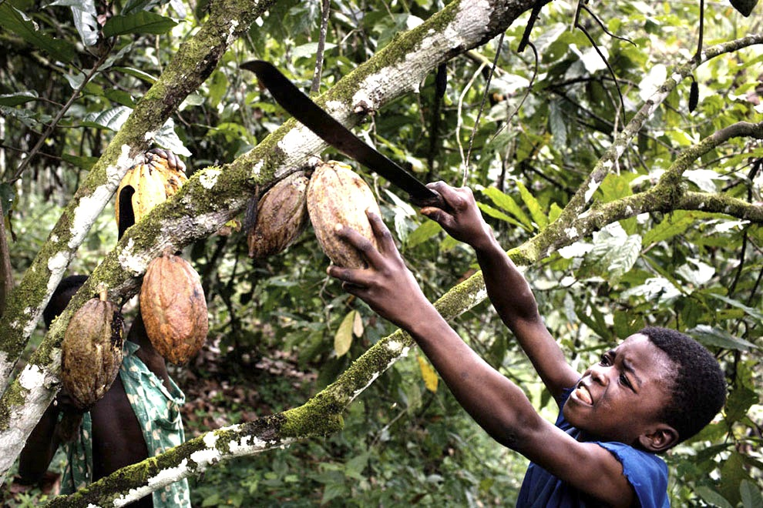

**Loss of (not often)**

**LEFT**

**RIGHT**

**Shift to the:**

**Improvements**

**Increases**

**Shift to the:**

**RIGHT**

**LEFT**

**Decreases**

**What factors would cause a SHIFT in demand for coffee?**



**10**

**40**

**25**

**$1.25**

**SHIFTS** in the supplycurve



**Government**



**Shift to the:**

**RIGHT**

**LEFT**

**Increase**

**Decrease**

**Increase**

**Decrease**

**RIGHT**

**LEFT**

**Shift to the:**

**Reduced or Cut**

**Increases**

**Shift to the:**

**RIGHT**

**LEFT**