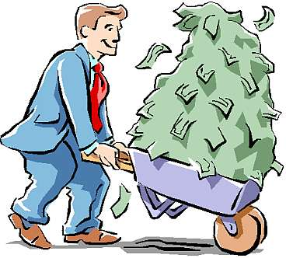

**(would buy same amount regardless)**

**(would buy less)**

**(would buy more)**

**IF NO shift:**

**INFERIOR**

**GOOD**

**NORMAL**

**GOOD**

**NEUTRAL**

**GOOD**

**Shift to the:**

**RIGHT**

**LEFT**

**Increases**

**Decreases**

**Income**

**What factors would cause a SHIFT in demand for coffee?**

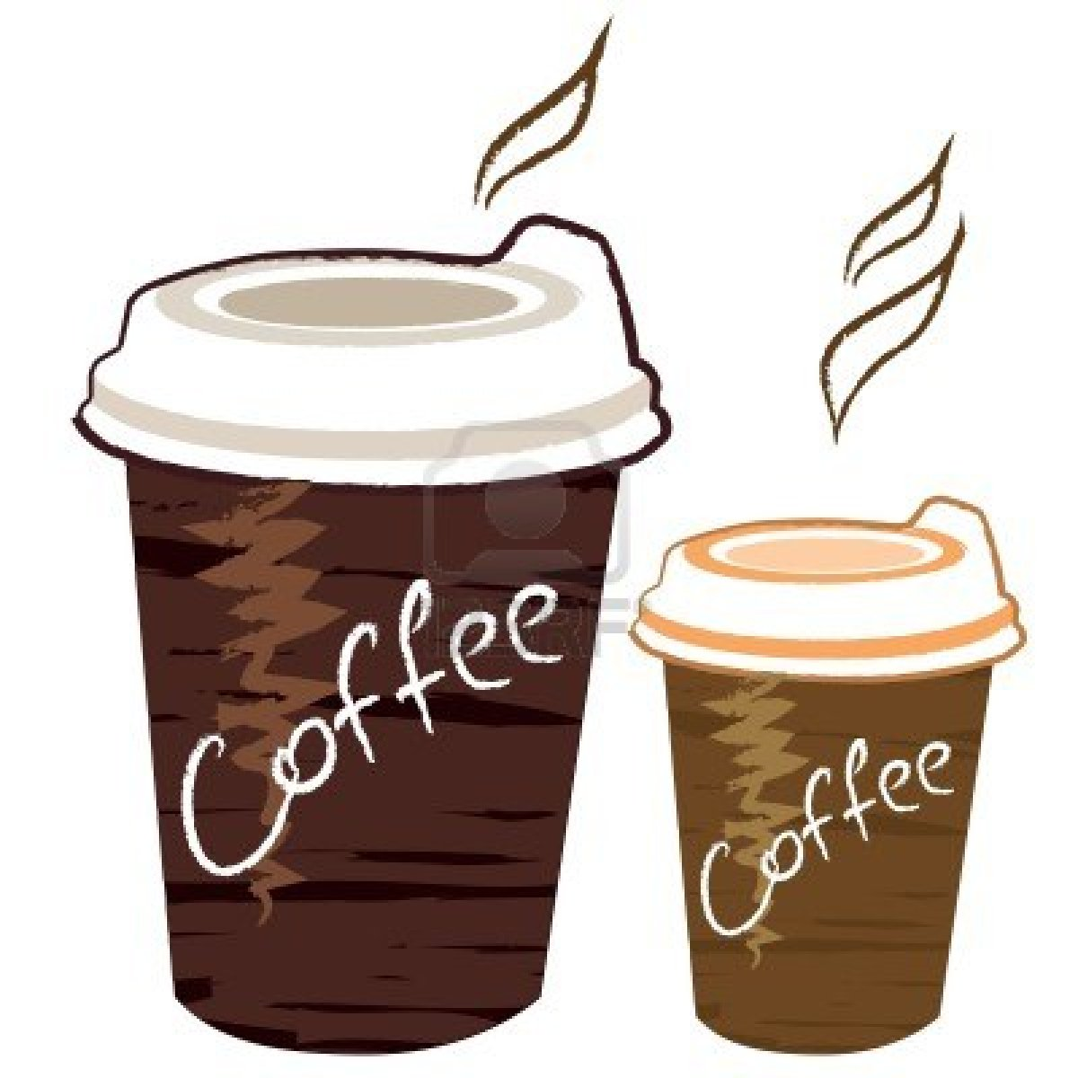

**10**

**40**

**25**

**$1.25**

**SHIFTS** in the demandcurve

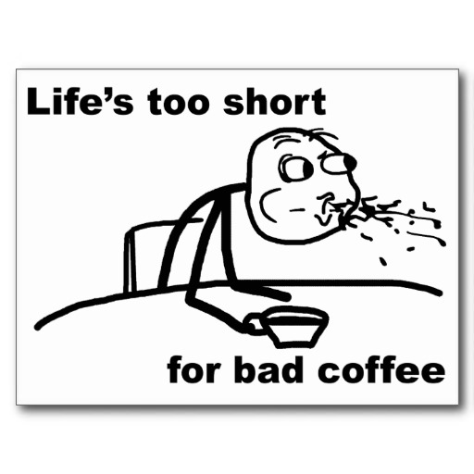

**Preferences (Taste) /**

**Advertising**

**Expectations**

**Shift to the:**

**LEFT**

**RIGHT**

**LEFT**

**RIGHT**

**Shift to the:**

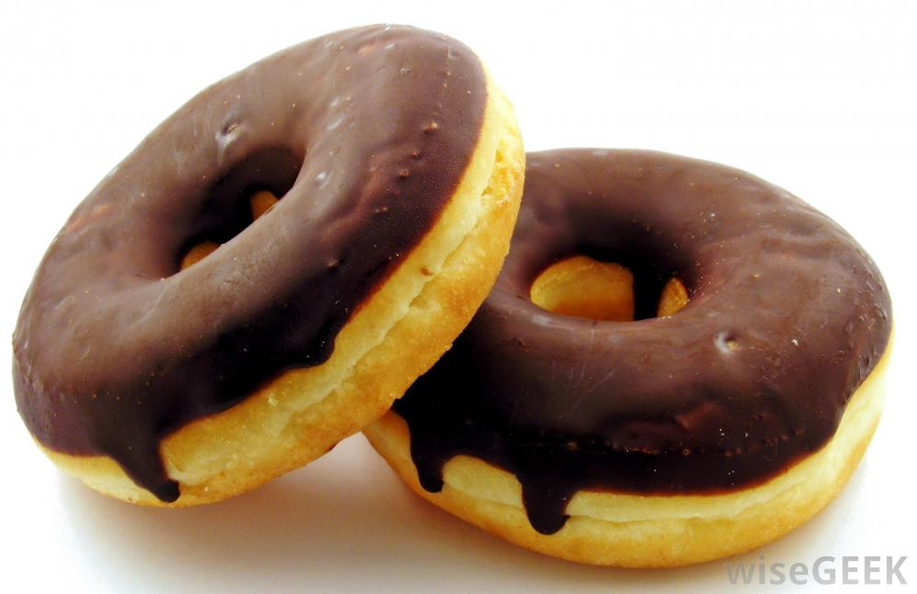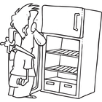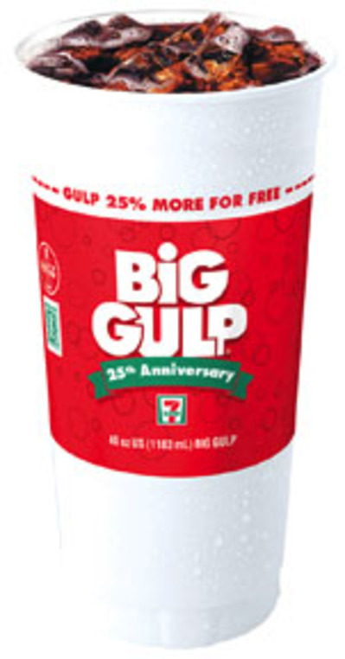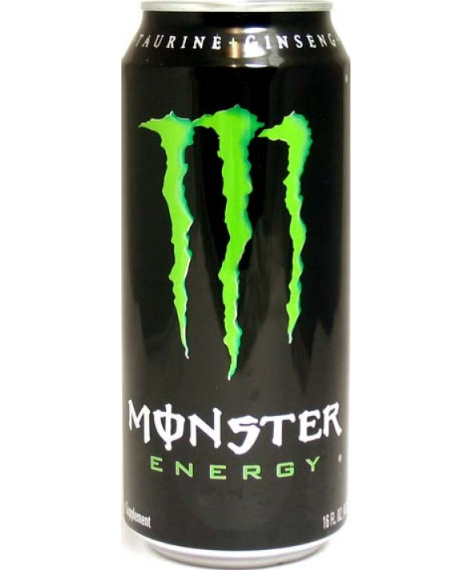

**Don’t Like Anymore**

**You Like More**

**SUBSTITUTES**

**COMPLEMENTS**

**RIGHT**



**Shift to the:**

**LEFT**

**RIGHT**

**Price of Related Goods**

**LEFT**

**Shift to the:**